*5.6 Software Development*

**Investor Centre Ltd Software Development**

**Overview**

The system is a forex trading platform built with Python and SQLite. The codebase consists of two primary files: db_setup.py and data_access.py. The db_setup.py file contains the database definitions and initialization process, creating the main SQLite database (main.db) with tables for customers, staff, trading orders, transaction history, and payment processing. data_access.py provides the data access layer with functions for account management, authentication, order processing, trade operations, payment handling, and financial calculations.

The platform implements secure user authentication with salted password hashing. It supports currency trading operations where users can place buy/sell orders on various currency pairs, view their trading history, and manage their account balance. The system calculates profit/loss based on pip differences and maintains comprehensive transaction records. The payment processing system allows users to add, modify, and delete payment methods with proper billing information. Additional features include trade history export to CSV and real-time exchange rate fetching via an external API.

**Database Tables**

*customers*

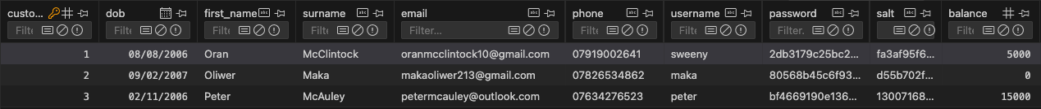

*staff*

**

*orders*

*history*

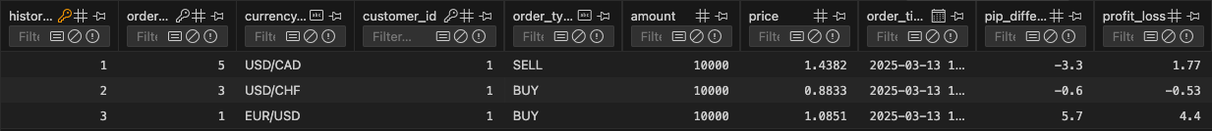

*payment_card*

**

*billing_address*

*card_provider*

*customer_payment_card*

